

**BHARATI VIDYAPEETH COLLEGE OF ENGINEERING,**

**SECTOR 7, OPPOSITE KHARGHAR RAILWAY STATION, CBD BELAPUR,**

**NAVI MUMBAI – 400614**

PROJECT REPORT ON:

**“****Website Landing Page using HTML,CSS & Bootstrap 4 for a Start-Up Company”**

**Submitted By:-**

**Radhika Ravindra**

**Vanashree Pawashe**

**Soha Randhir**

**Anuja Raut**

**Under The Guidance Of:**

**Prof. Shekhar Mane**

**2019-2020**



**BHARATI VIDYAPEETH COLLEGE OF ENGINEERING,**

**SECTOR 7, OPPOSITE KHARGHAR RAILWAY STATION, CBD BELAPUR,**

**NAVI MUMBAI – 400614**

**CERTIFICATE**

This is to certify that the students of third year of department **Electronics and Telecommunication Engineering** have successfully completed a report on **Website Landing Page using HTML,CSS & Bootstrap 4 for a Start-Up Company**  fulfilment of the requirement in the course **OPEN SOURCE TECHNOLOGY FOR COMMUNICATION LAB PROJECT** as prescribed in the syllabus by the **UNIVERSITY OF MUMBAI.**

Radhika Ravindra

Vanashree Pawashe

Soha Randhir

Anuja Raut

**Prof. Shekhar Mane**

**(GUIDE)**

|  |  |  |
| --- | --- | --- |
| **Sr. No** | **Content** | **Page No.** |
| 1 | INTRODUCTION | 3 |
| 2 | WEB DESIGNING | 4 |
| 3 | HTML | 5 |
| 4 | CSS & BOOTSTRAP 4 | 6 |
| 5 | OUTPUT | 7 |
| 6 | CONCLUSION | 10 |

**INDEX**

**INTRODUCTION**

Web design is the process of creating websites. It encompasses several different aspects, including webpage layout, content production, and graphic design. While the terms web design and web development are often used interchangeably, web design is technically a subset of the broader category of web development.

Websites are created using a markup language called HTML. Web designers build webpages using HTML tags that define the content and metadata of each page. The layout and appearance of the elements within a webpage are typically defined using CSS, or cascading style sheets. Therefore, most websites include a combination of HTML and CSS that defines how each page will appear in a browser.

In this project we will be concerned majorly upon the front end development, i.e. website landing page of the start-up company called Museum of Candy.

**WEB DESIGNING**

Web design is a Web development process for creating a website that focuses on aesthetic factors like layout, user interface and other visual imagery in order to make the website more visually appealing and easy to use. Web design makes use of various programs and tools in order to achieve the intended look, such as Dreamweaver, Photoshop and many others. In order to create a winning design, Web designers need to think about their audience, the purpose of the website and the visual appeal of the design.

User experience design and interactive design

User understanding of the content of a website often depends on user understanding of how the website works. This is part of the user experience design. User experience is related to layout, clear instructions and labelling on a website.

Page layout

Part of the user interface design is affected by the quality of the page layout. For example, a designer may consider whether the site's page layout should remain consistent on different pages when designing the layout.

Quality of code

Website designers may consider it to be good practice to conform to standards. This is usually done via a description specifying what the element is doing. Failure to conform to standards may not make a website unusable or error prone, but standards can relate to the correct layout of pages for readability as well making sure coded elements are closed appropriately.

**HTML**

HTML5 is the latest version of Hypertext Markup Language, the code that describes web pages. It's actually three kinds of code: HTML, which provides the structure; Cascading Style Sheets (CSS), which take care of presentation; and JavaScript, which makes things happen.

HTML5 has been designed to deliver almost everything you'd want to do online without requiring additional software such as browser plugins. It does everything from animation to apps, music to movies, and can also be used to build incredibly complicated applications that run in your browser.

There's more. HTML5 isn't proprietary, so you don't need to pay royalties to use it. It's also cross-platform, which means it doesn't care whether you're using a tablet or a smartphone, a netbook, notebook or ultrabook or a Smart TV: if your browser supports HTML5, it should work flawlessly. Inevitably, it's a bit more complicated than that.

HTML 5 introduces elements and attributes that reflect typical usage on modern websites. Some of them are semantic replacements for common uses of generic block (<div>) and inline (<span>) elements, for example <nav> (website navigation block), <footer> (usually referring to bottom of web page or to last lines of HTML code), or <audio> and <video> instead of <object>.

**CSS & BOOTSTRAP 4**

Cascading Style Sheets (CSS) is a stylesheet language used to describe the presentation of a document written in HTML or XML (including XML dialects such as SVG, MathML or XHTML). CSS describes how elements should be rendered on screen, on paper, in speech, or on other media.

CSS is one of the core languages of the open Web and is standardized across Web browsers. Bootstrap is a free and open-source CSS framework directed at responsive, mobile-first front-end web development. It contains CSS- and (optionally) JavaScript-based design templates for typography, forms, buttons, navigation and other interface components.

Bootstrap is a web framework that focuses on simplifying the development of informative web pages (as opposed to web apps). The primary purpose of adding it to a web project is to apply Bootstrap's choices of colour, size, font and layout to that project. As such, the primary factor is whether the developers in charge find those choices to their liking. Once added to a project, Bootstrap provides basic style definitions for all HTML elements. The result is a uniform appearance for prose, tables and form elements across web browsers. In addition, developers can take advantage of CSS classes defined in Bootstrap to further customize the appearance of their contents. For example, Bootstrap has provisioned for light- and dark-coloured tables, page headings, more prominent pull quotes, and text with a highlight.

**OUTPUT**

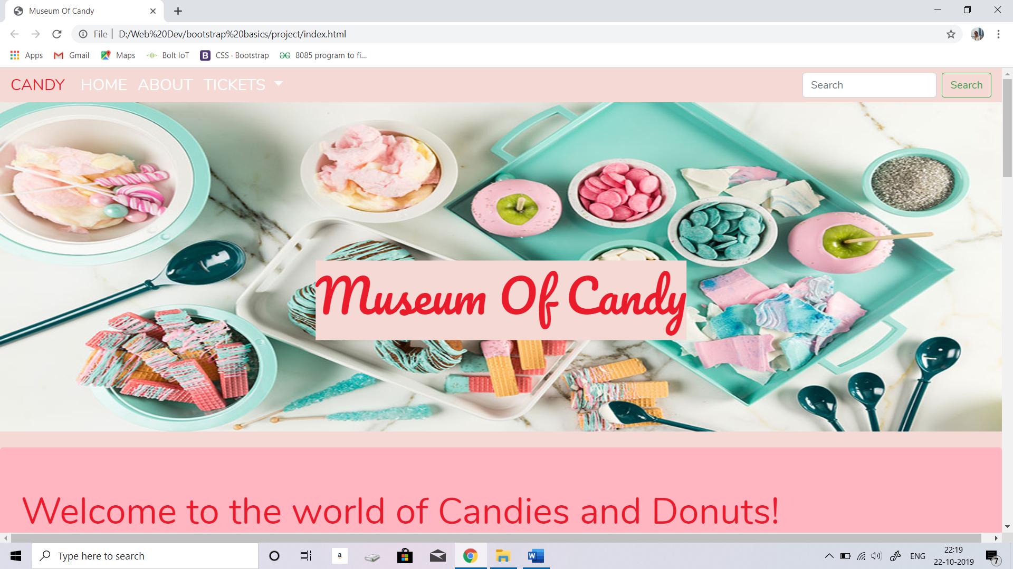

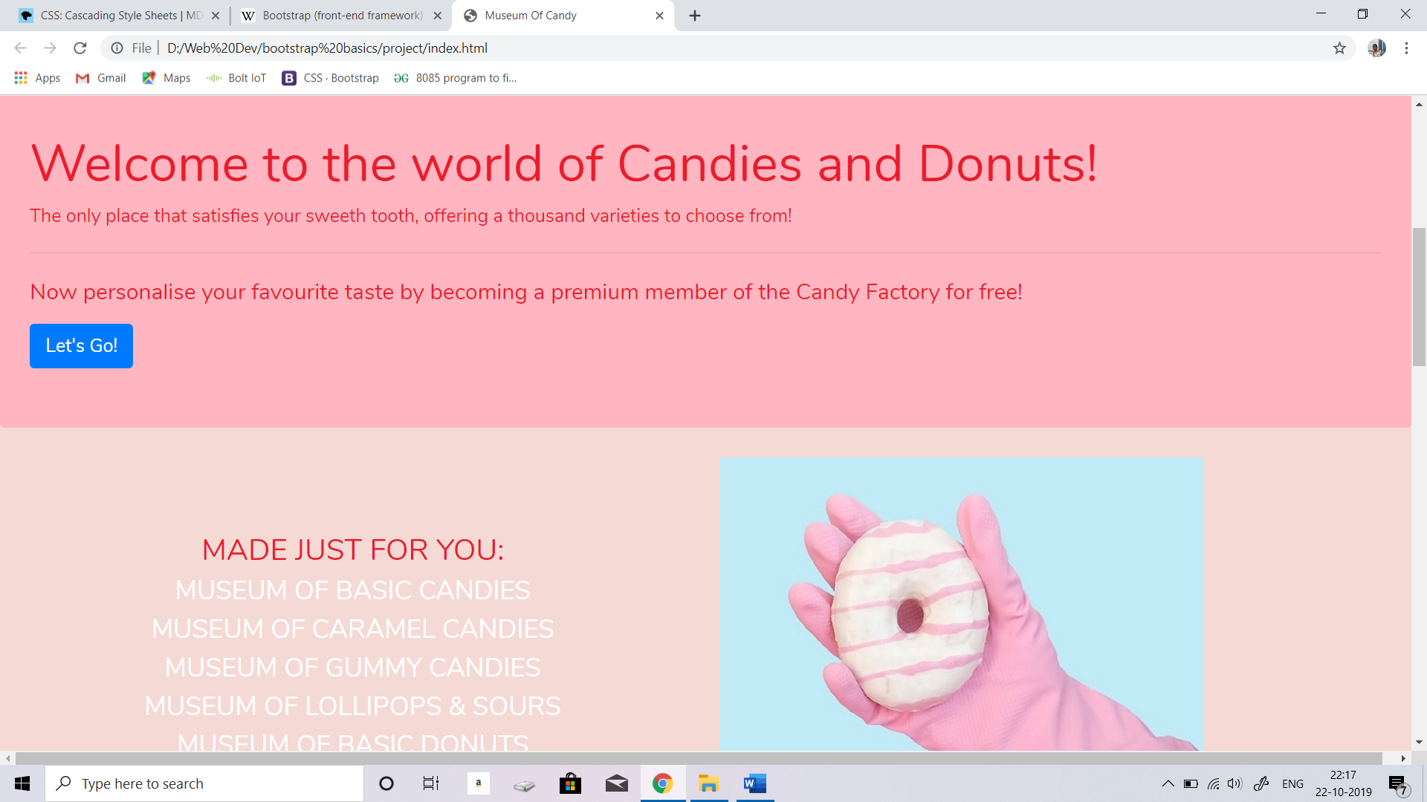

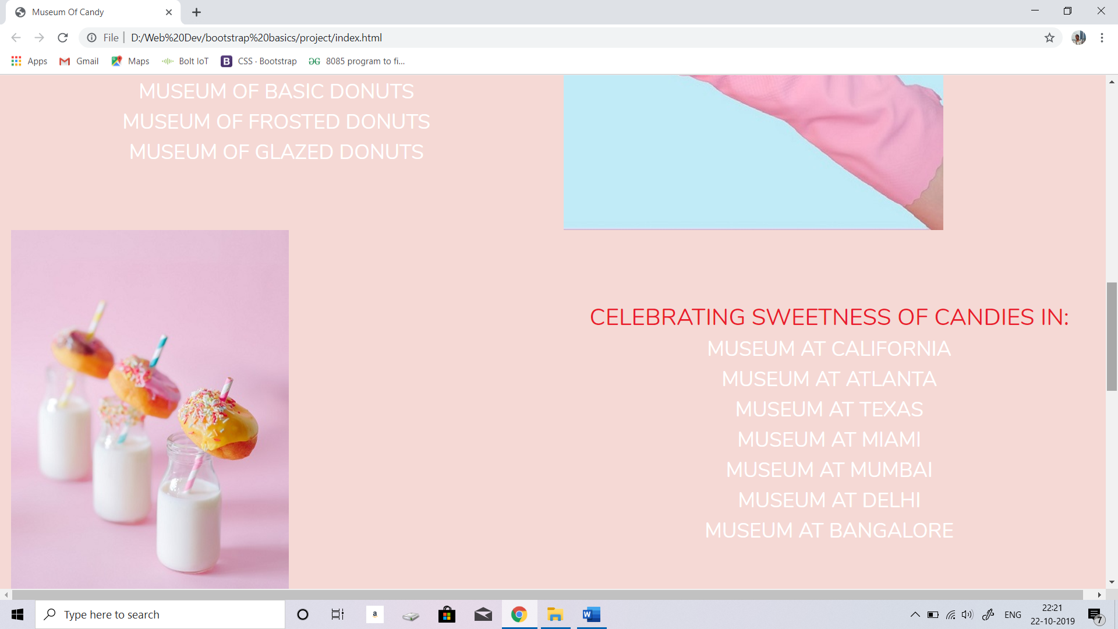

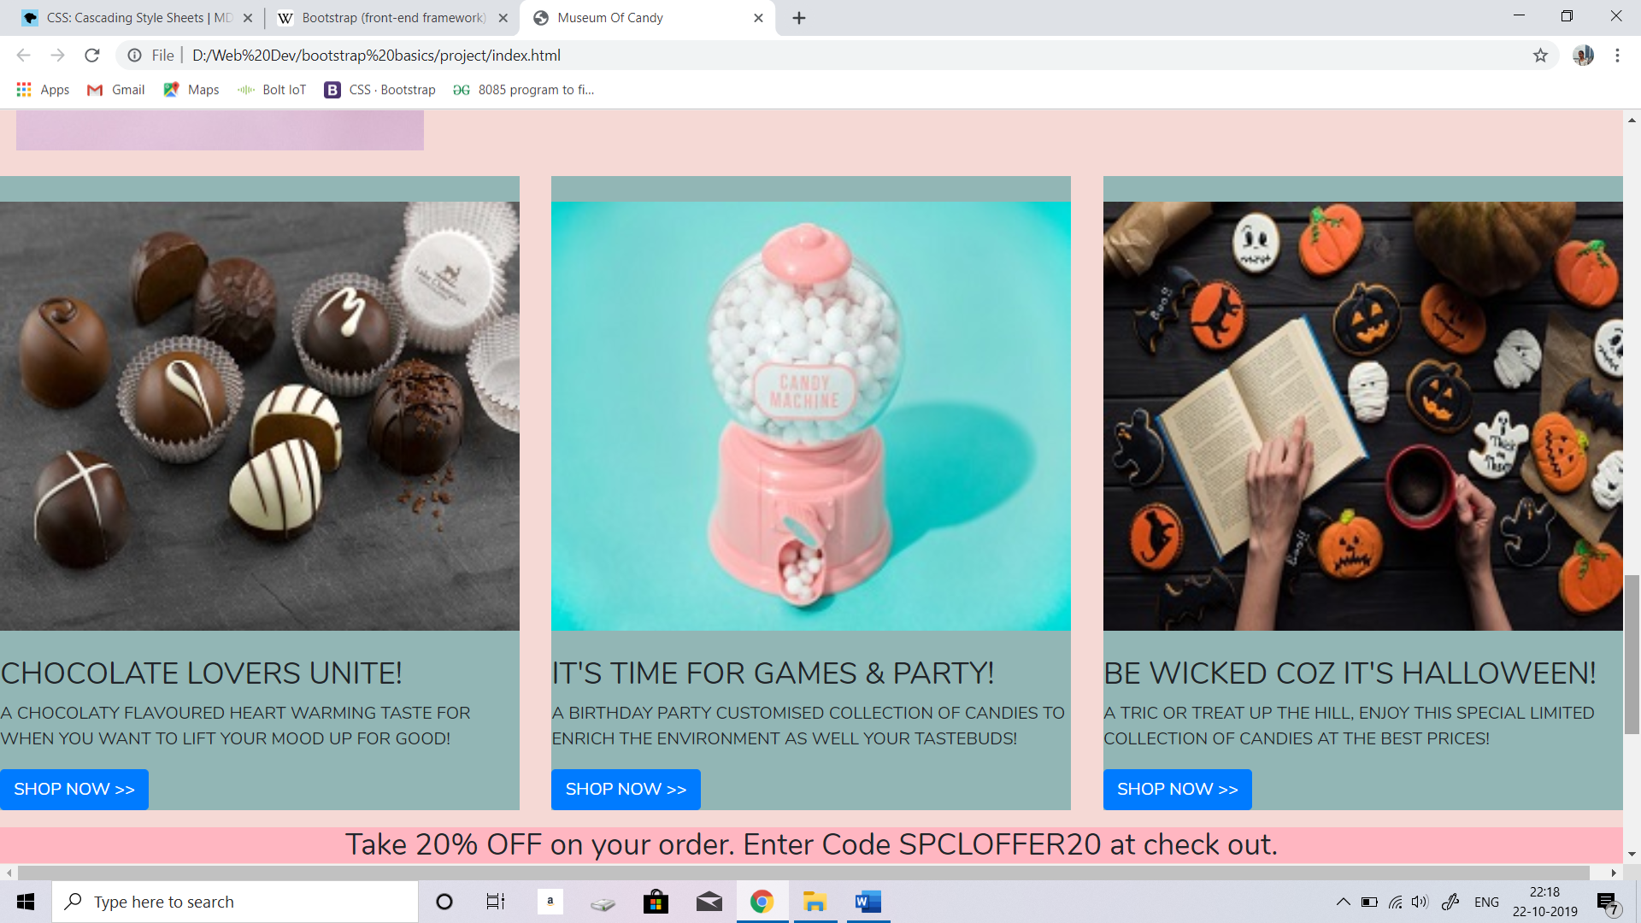

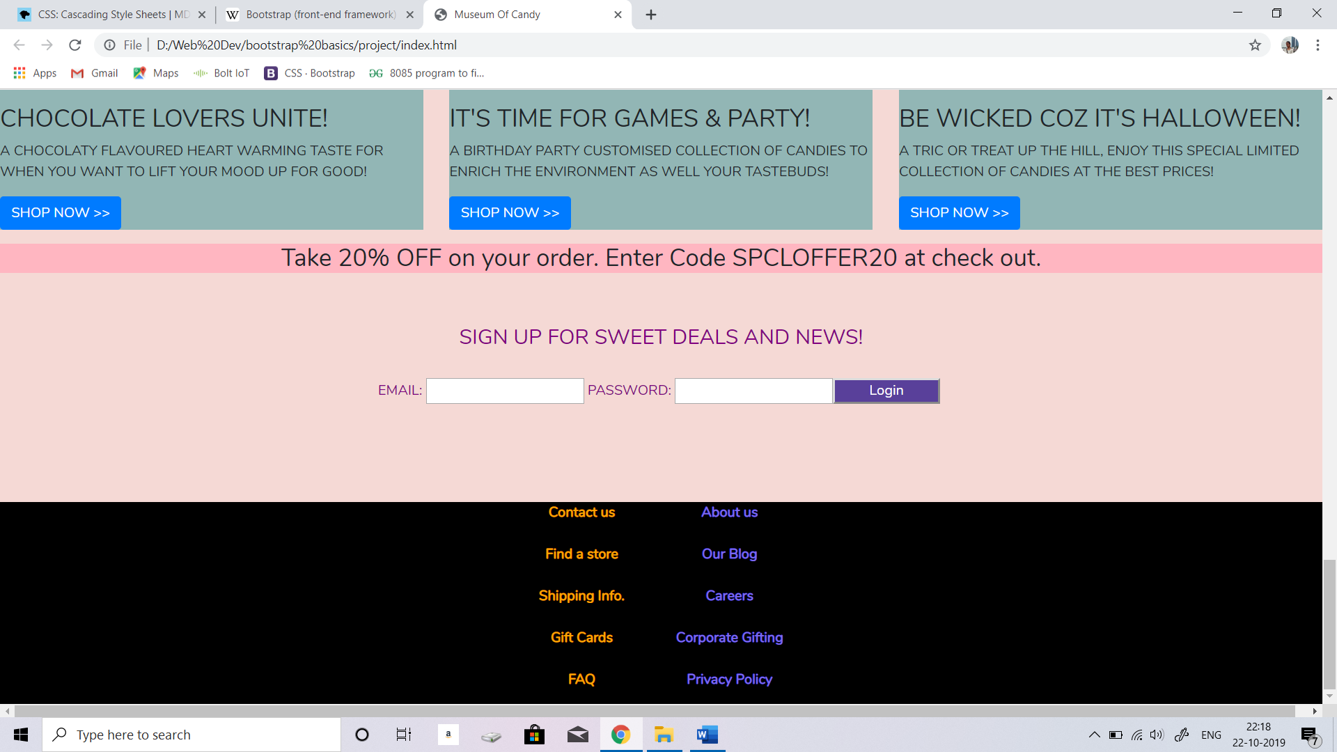

**CONCLUSION**

Thus, a website landing page for a start-up company called ‘Museum Of Candy’ has been created using HTML5, CSS and bootstrap 4 in a proper Integrated Development Environment (IDE). IDE used was Sublime text.